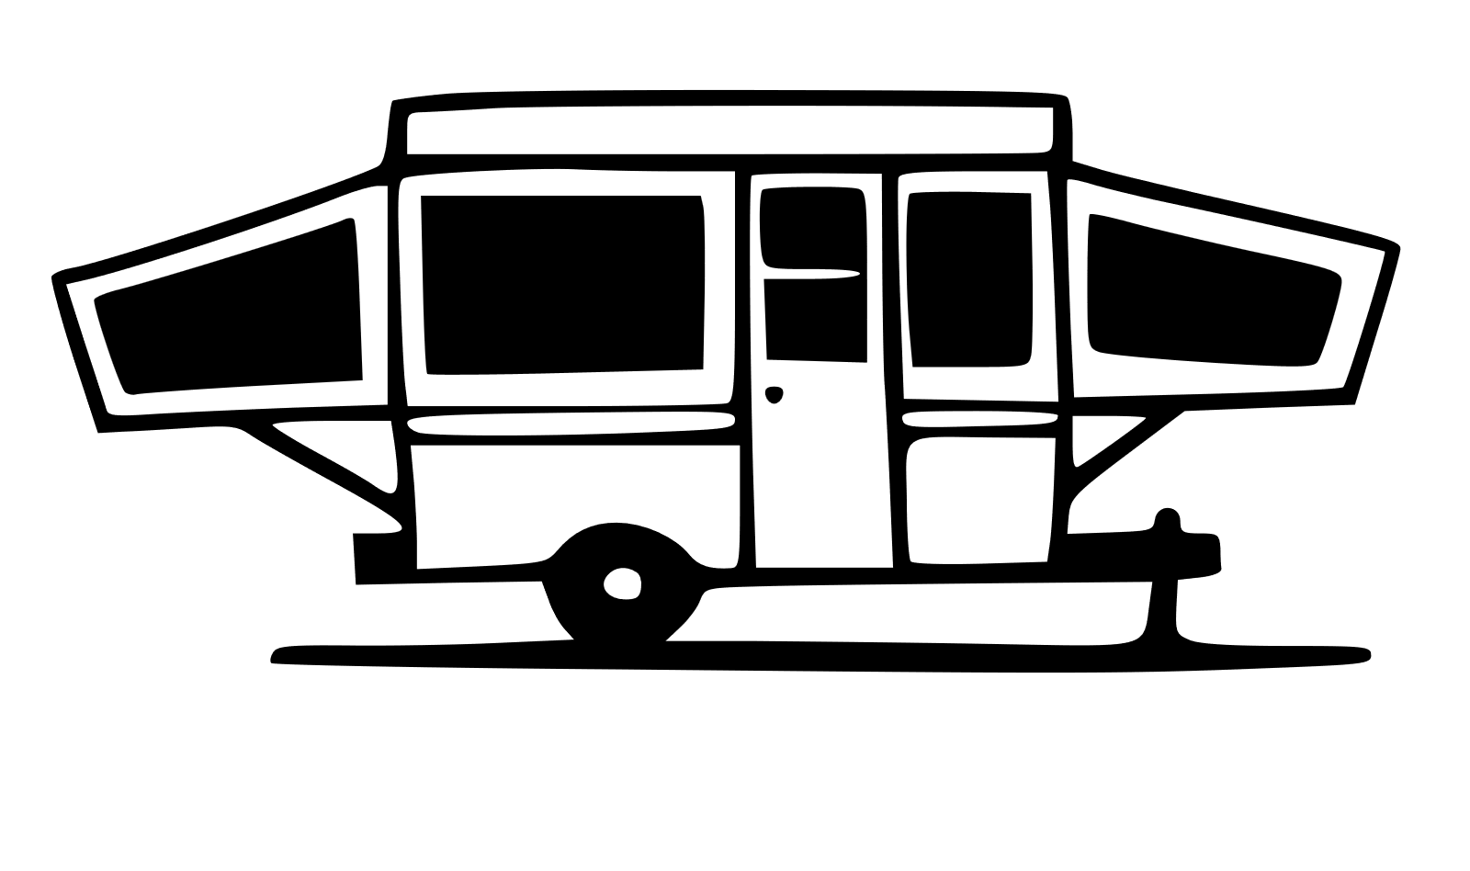
Layersforlife Guide

NOTE: blow out the system with air, then waits 24 hours and repeats to eliminate residual water.
Remember the air compressor puts out about 150 PSI, which will over-pressure your water system
NOTE: Some air compressors may introduce oil or other motor lubricants into the air tank, and thus into the air line. Know your compressor and avoid using one that may introduce contaminants into your RV drinking water.
1. You should have removed or bypassed all filters from your water system. See All Models -First Steps above.
2. Drain your water heater tank. Allow the water to cool completely before proceeding!
a.Verify that the water heater is OFF.
b.Open the vent at the top of the water heater.
c.Remove the nylon plug or sacrificial element (depending on your water heater model) from the bottom of the water heater tank and allow the water to drain out. It is normal for some sediment to come out as the tank empties.
d. remove residue in the tank,
3. Attach air compressor to the RV city water inlet or to a permanently attached RV water hose
4. Set air pressure to desired pressure (typically 40-55 PSI -err on the low side unless you know for certainthat higher pressure is safe for your RV).
5.Leave water heaterNORMALFLOW/BYPASS valve in NORMALFLOWposition initially.
6.Turn oncompressor and allow it to run for a few minutes. The small amount of water that flows into your water heater will not damage it should it freeze. You will bypass the water heater in the next step.NOTE:Steps 5-6are optional. These steps ensure the hot water line between the bypass valve and water heater are cleared. Because the water heater is empty, there is plenty room for expansion should the line freeze so damage is unlikelyshould you decide not to perform steps 5-6.
7.Set the water heaterNORMALFLOW/BYPASS valve lever to the BYPASSposition.NOTE:Setting the water heater NORMAL FLOW/BYPASSvalve to BYPASSmeans that water (or in this case, air) will notbe introduced into your water heater tank.
8.With the city waterBYPASS/FILLvalve in the BYPASSposition,letcompressorair pressure to build to your desired pressure setting.(At this point, city water and water heater valves should bothbe in the BYPASS position.)
9.Startingwith farthest faucet from water inlet, runwater from each hotwaterfaucetuntil only air escapes.
a.Bathroom sink(s).
b.Shower/Bathtub.
c.Kitchen sink.
d.External shower if equipped.
10.Close all hot water faucets and repeat step 9for coldwater faucets. Additionally include,
a.Clearing water from lines to toilets.
b.Toilet spray hoses and nozzles.
11.With everything else closed,place the city waterBYPASS/FILLvalve in the FILLpositionand blow air toward the fresh tankfor a short timeto clear the line between the valve and fresh water tank. (Thank you Marv McIntosh)
12.Return the city waterBYPASS/FILLvalve to the BYPASSposition.
13.Pour a cupful of antifreeze in each sink drain and toilet. Flush toilets to put antifreeze on the toilet valve mechanism.NOTE:Thetford Techma Toilet Procedure
a.Flush until water is purged and air escapes.
b.Pour 2 cups antifreeze in toilet and flush to winterize waste delivery line between toilet and black tank. Perform this 3-5 times (5 is recommended by manufacturer).
c.Pour 2 cups antifreeze in toilet when step bis complete.
14.Introduce a small amount (about a cup full) of antifreeze through on-board water pump to winterize the pump. You can also simply run the pump “dry” for a few minutes to purge any water from it, but a little antifreeze is a safe option.
15.Winterize refrigerator water as appropriate.
16.Replace the water heater tank plug and close the relief valve at the top of the tank to prevent bugs/dust from entering the tank (optional, but keeps critters out).
17.When all winterization steps (including appliances) have been completed, RE-OPENlow point drains and all faucets. This provides a potential path for expansion and protectsfittingsif any residual water remainingin the system freezes.

UNWINTERIZING
1.ALWAYSBE LOOKING FOR LEAKS AT EVERY STEPDURING THIS ENTIRE PROCESS
2.CLOSElow-point water drains and leave water heaterNORMAL FLOW/BYPASSvalve in BYPASSposition.
3.Fill fresh water tank to desired level (This would be a good time to sanitize the fresh water tank).
4.Using the on-board water pump, run fresh water from the fresh water tank through system to clear any pink liquid from water pump and input lines.
5.Using either the on-board water pump or city water, run hot and coldwater from each faucet, shower, and toilet(don’t forget externalshower) until water runs clear.
6.Verify external shower knobs are in the OFFposition.
7.Change water heaterNORMAL FLOW/BYPASSvalve from BYPASS to NORMAL FLOW.
8.Verify water heater drain plug is inserted and tight and close pressure/temperature relief valve (If you have an anoderod, now is the time to inspect and/or replace it).
9.Open hot water faucet near water heater.
10.Turn on water source to fill water heater(This is often easier and more quickly done with city water connectedrather than water pumped from the fresh water tank.Either can be used.
11.Fill water heateruntil air is voided at the pressure/temperature valve or hot water faucet near water heater(See Q/A Topic7 about necessary expansion pocket).
12.Close hot water faucet and or pressure temperature valve when water heater is full.
13.Turn Hot Water Propane or Electric heat on, as you normally would (Optional).
14.Replaceitems that were susceptible to freezing and removed during winterization.
a.Coffee pot.
b.Dish soap.
c.First-aid supplies.
d.Make-up.

POST-UNWINTERIZINGINSPECTIONS
These are the things you should do or check after unwinterizing and before the first time out.
A: Galley Stove
a.Have patience. Idea is to light the burner –not ignite the air around and above it.
b.Verify Propane is turned on.
c.Attempt to light one galleystove burner.
d.Push sparker knob in until you smell propane (rotten egg smell).You can also use a butane lighter wand and hold it close to the burner until it lights).
e.Wait at least 2 minutes (5 is better), then attempt to light the burner.
f.If burner doesn’t light in a few seconds, wait a few minutes, then try again.
g.After 1 burner lights, exercise the other burners to verify each operates correctly.
B: Batteries (Exercise proper battery safety at all times)
a.Clean batteries and battery compartment with baking soda/water solution and rinse.
b.Top off distilled water in house batteries.
c.Check battery connections for corrosion; clean if necessary.
d.Verify battery connections are all secure.
C: Tires (Have them professionally inspected every two years)
a.Inspectfor (especially abnormal) wear.
b.Inspect sidewalls for weather cracks.
c.Check air pressures (based on corner weights if you know them).
D: Water Heater
a.Turn on water heater usingpropane sourcefirsttoverify waterheater flame ignites and stays lit for about at least aminuteor two (if it stayed lit that long, it is probably working correctly).
b.Shut off water heaterand turn back on, this timewith electric source,and leave onto verify that it is heating the water fully

Fresh Water Tank(Sanitize)
a.Remove filtersbefore sanitizingor replace them after sanitizing.
b.Drain Tank.
c.Mix ¼ to ½ cup bleach/15-gal water and refill tank.
d.Turn hot water heaterNORMAL FLOW/BYPASS to the BYPASSposition.
e.Using water pump run water through the entire system. Open each hot and cold faucet until you smell bleach.1.Showers.2.All sink faucets.3.Toilets.4.Refrigerator water/ice maker.
f.Let it sit for at least 4 hours; overnight is better.
g.Drain fresh water tank and refill.
h.Run fresh water through entire system until no bleach smell.
i.If needed, repeat drain/refill/system flush again.

Miscellaneous
a.Inspect carefully for any signs of critters.1.Webs.2.Droppings.3.Etc.4.Clean and disinfect if necessary.
b.Smoke, Propane, Carbon Monoxide Detectors.1.Know where they are and what each is for.2.Replace batteries annually if battery operated.3.Test each detector and always test before each trip.
c.Lubricate locks with graphite-based lubricant.
d.Lubricate all step joints (Silicon NOT recommended. Use a non-stickinglubricant such asDuPont Non-Stick Dry Film Lubricant with Teflon or Boeshield T-9).
e.Clean and lubricate Jacks.
f.Check (particularly on roof) for cracked or pealing sealants (Be sure to use the CORRECT sealant for any resealing).
g.Inspect, clean, and treat rubber seals. (Use products such asProtect All Slide-Out RubberSeal Treatment –available on Amazon).
h.Check around windows for leaks.

